|  |  |  |  |  |  |
| --- | --- | --- | --- | --- | --- |
| Date | 15-Jun-22 | | | Tester Name | Mohammad Yusuf |
| Environment | Penfax - Test | | | Login used |  |
| Operating System | Select OS | Version: | Update: | | |
| Software Used | Select Software | Version: | Update: | | |
| Select Software | Version: | Update: | | |
| Release version |  | | | | |
| Title | M17 Contributions & DCT | | | | |
| Test Type | Regression | | | | |
| Test Scenario | M17.25 Edit File Headers on a Contribution File | | | | |
|  |  | | | | |
| Expected Results | Pay Cycle and Pay Period should be editable and saved. | | | | |
| Pass/Fail | Pass | | | JIRA# | N/A |

Describe your steps with screenshots:

1. Log into MEPP DCT and select the Employer from the dropdown.

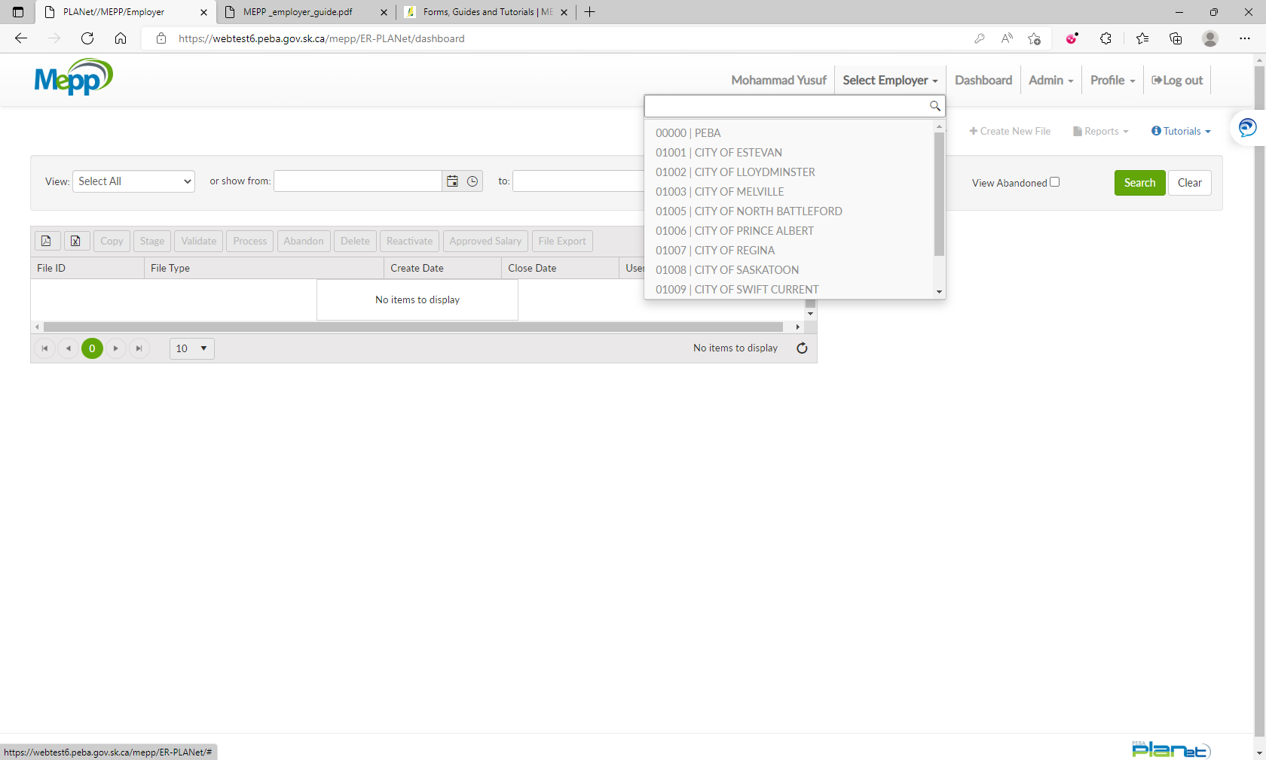

1. Click on Create New File.

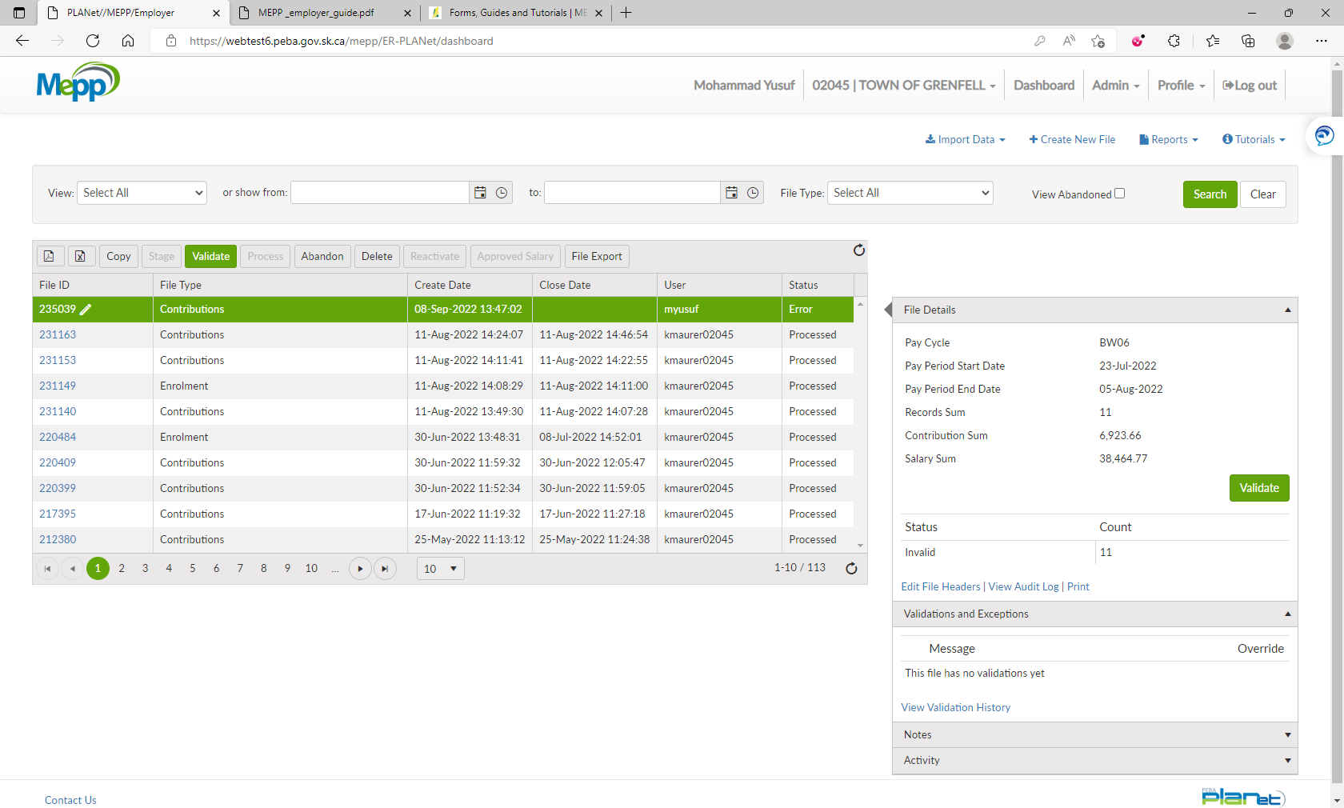

1. Select Contribution from the dropdown.

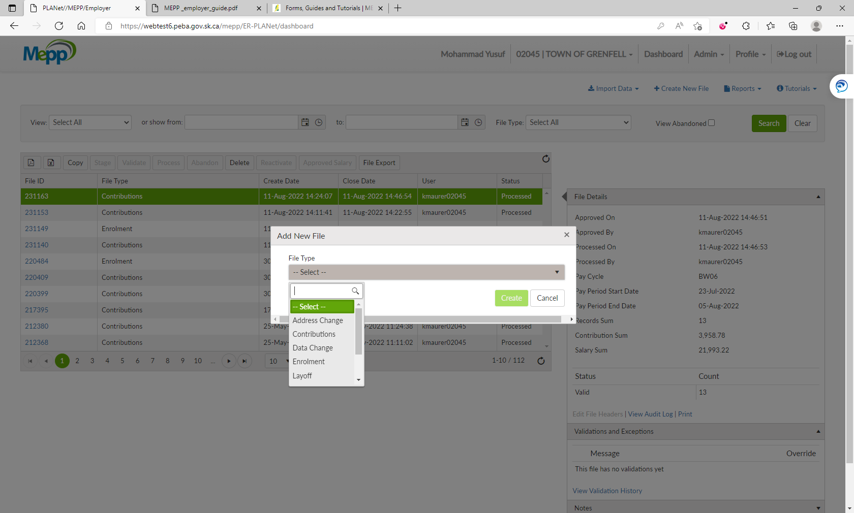

1. Input Pay Cycle and Pay Period and click on Create.

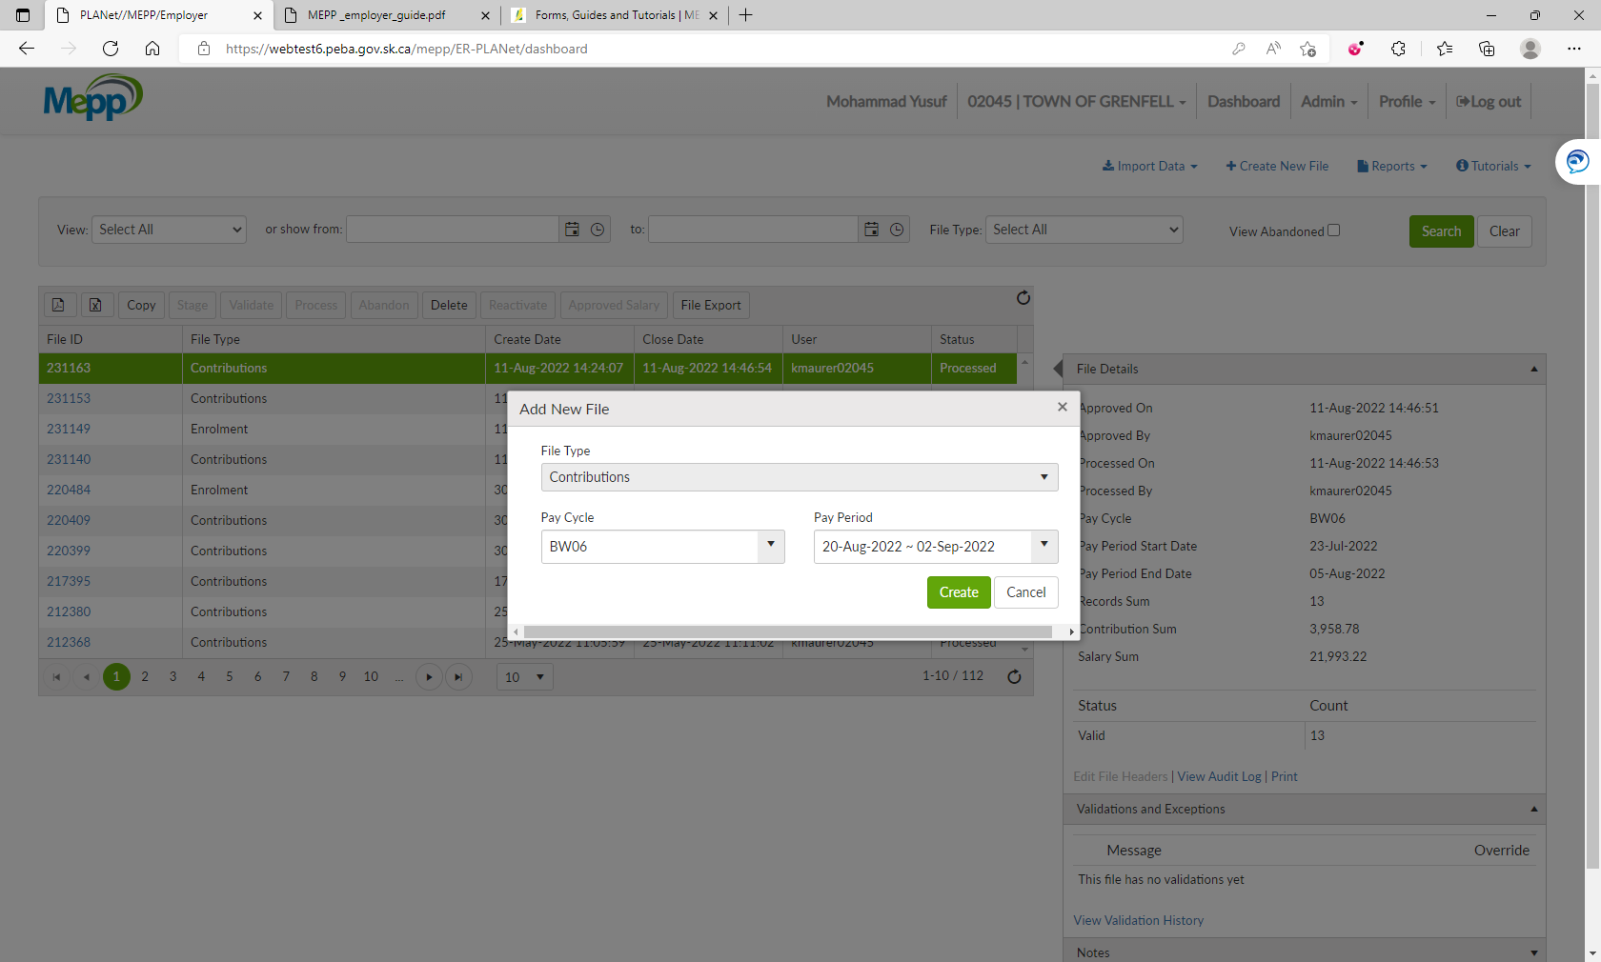

1. Click on File ID.

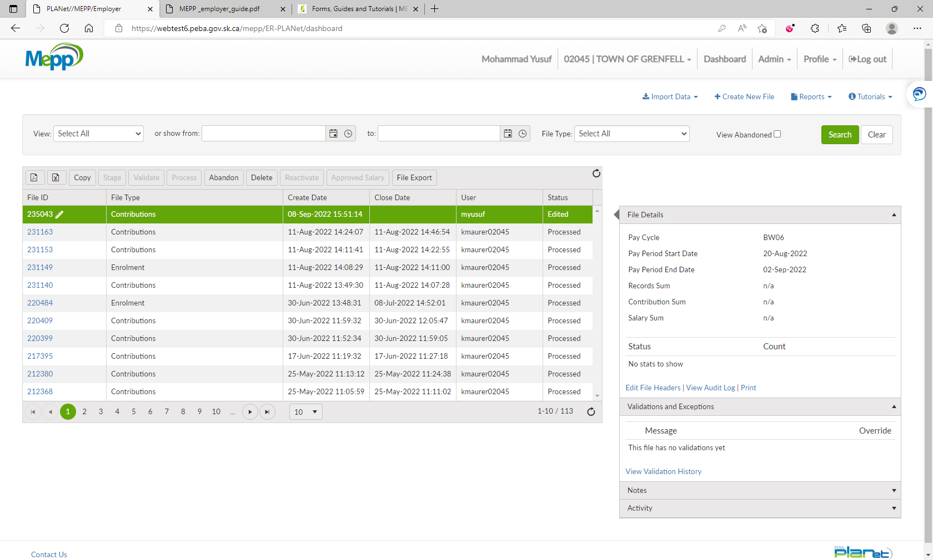

1. Click on Add to add the transactions.

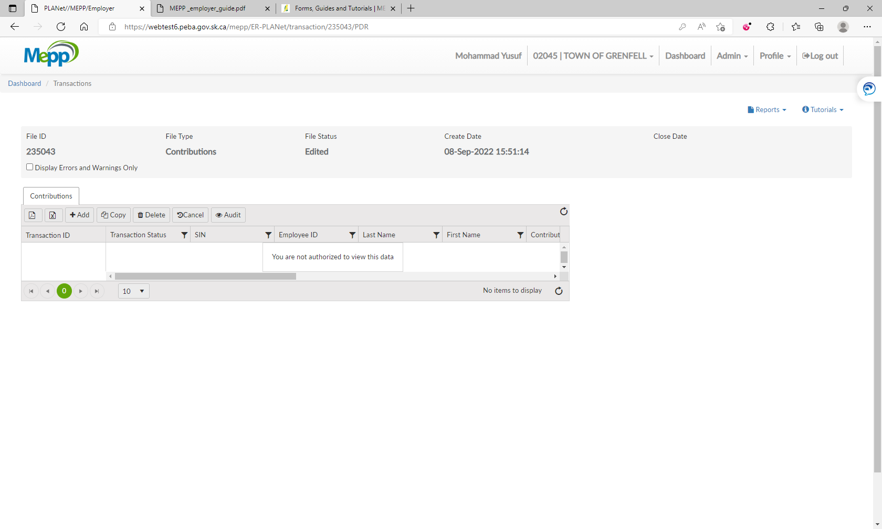

1. Input all the required details and Save.

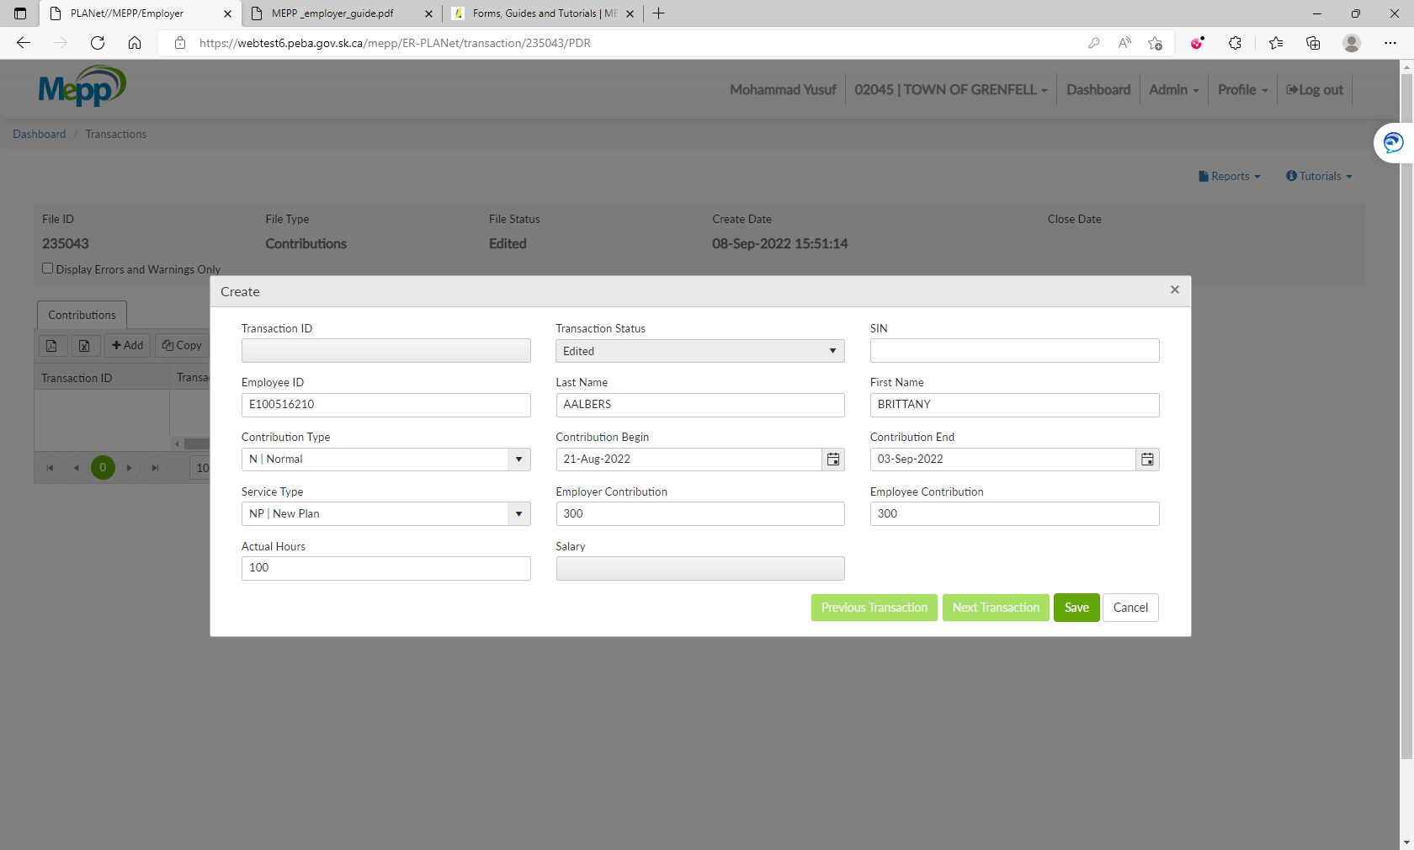

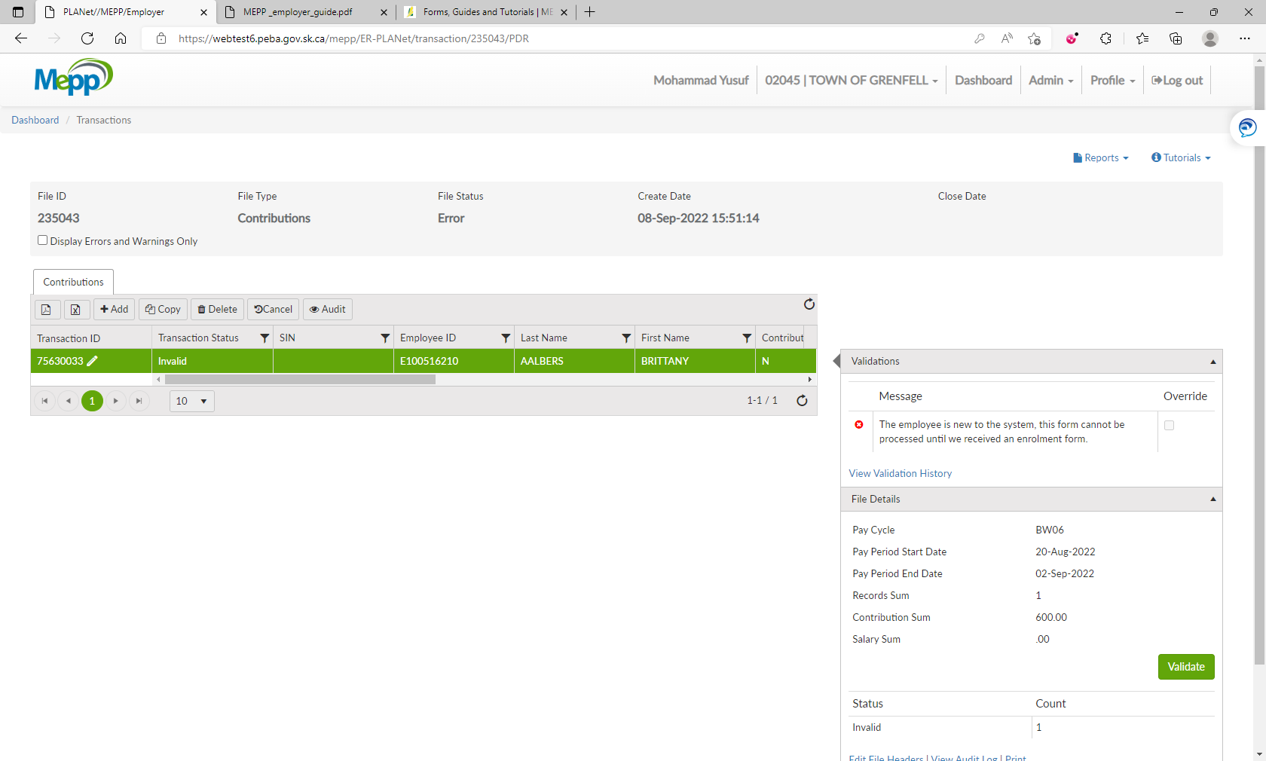

Perform the same steps for employer 10208

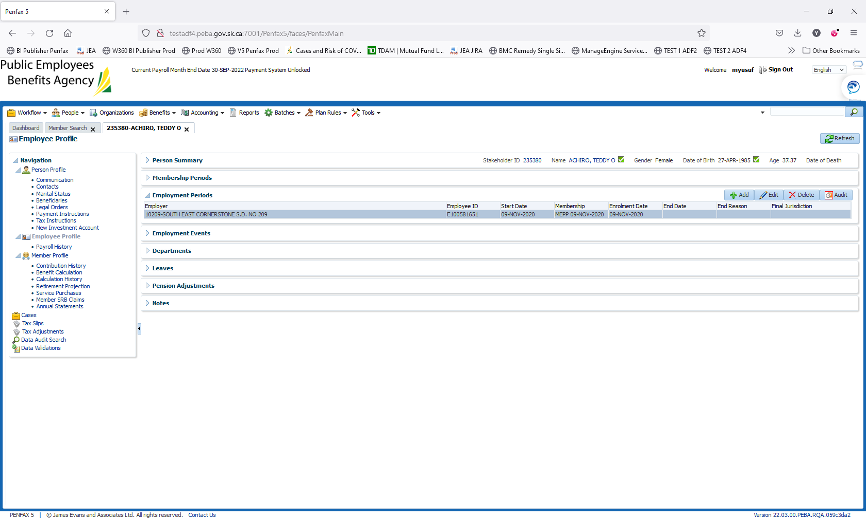

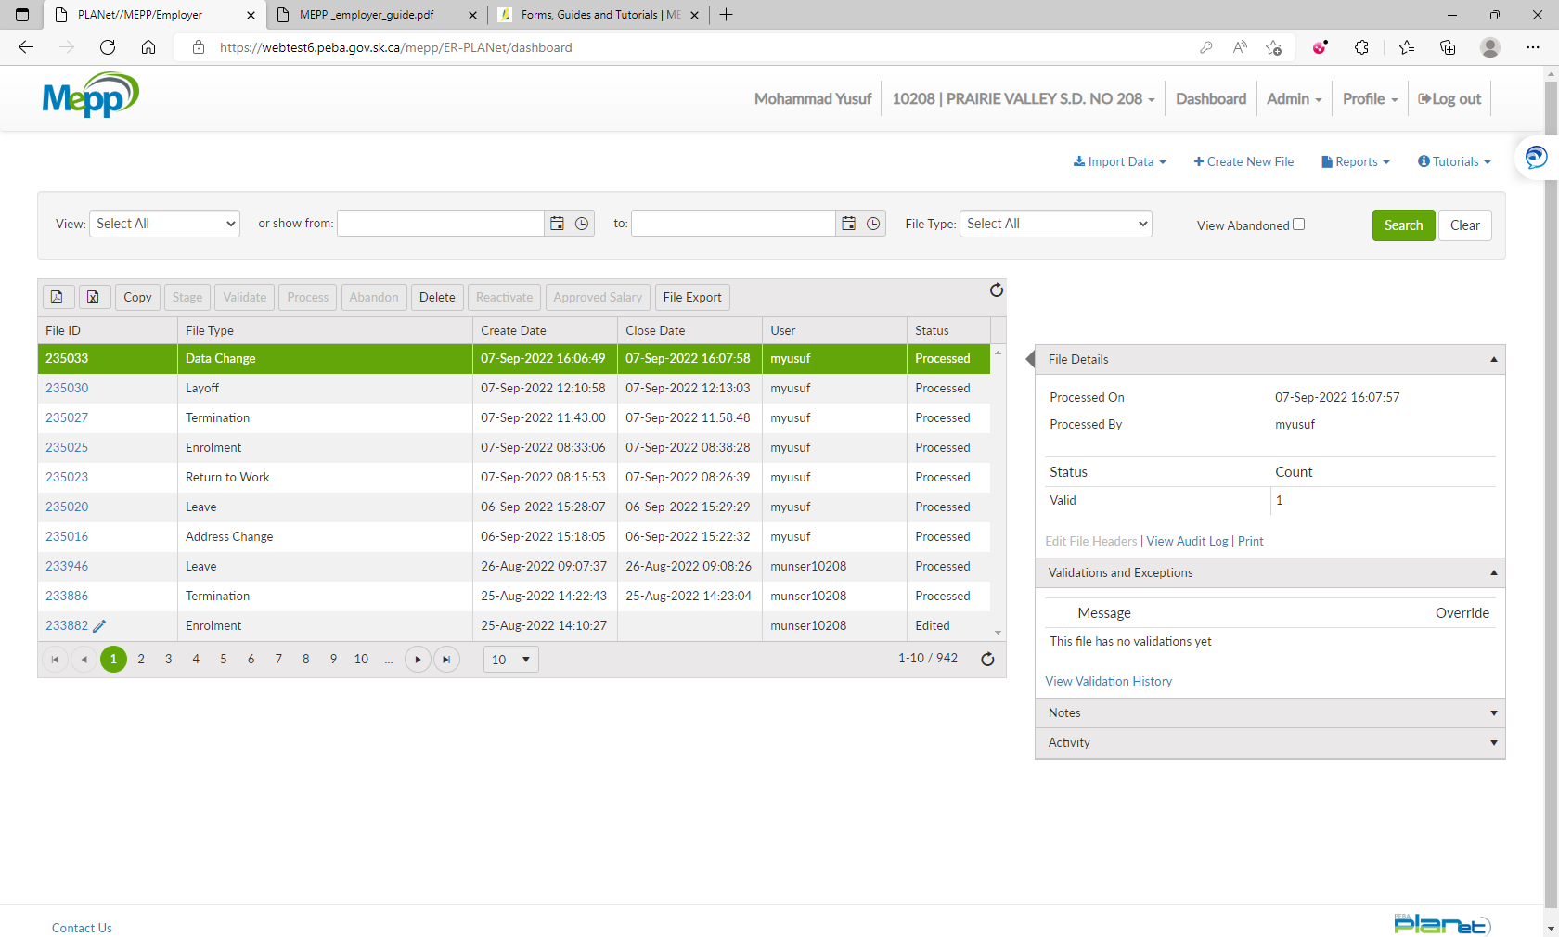

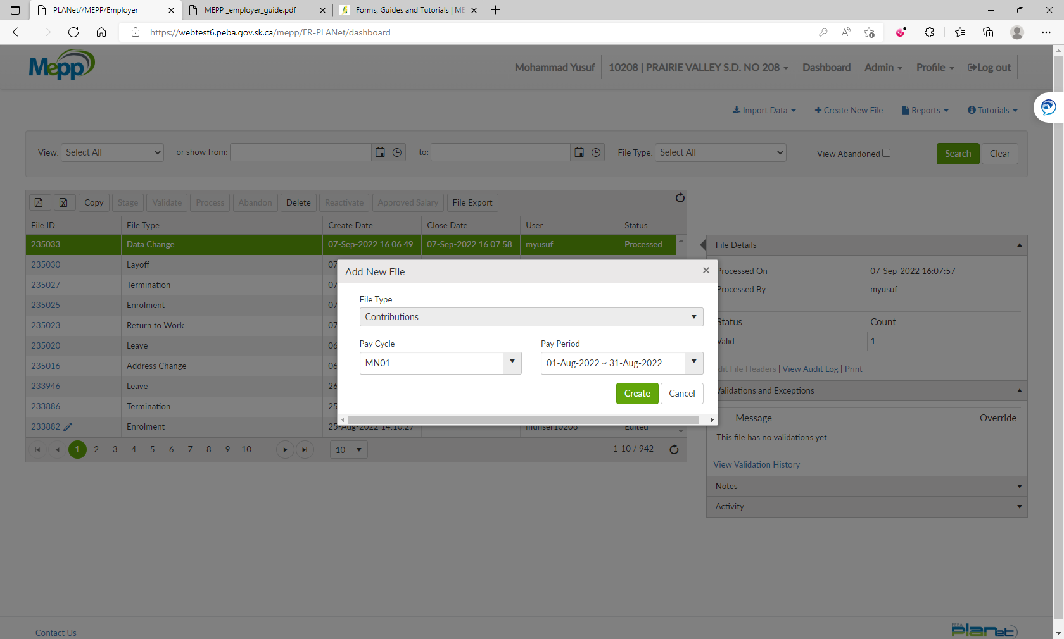

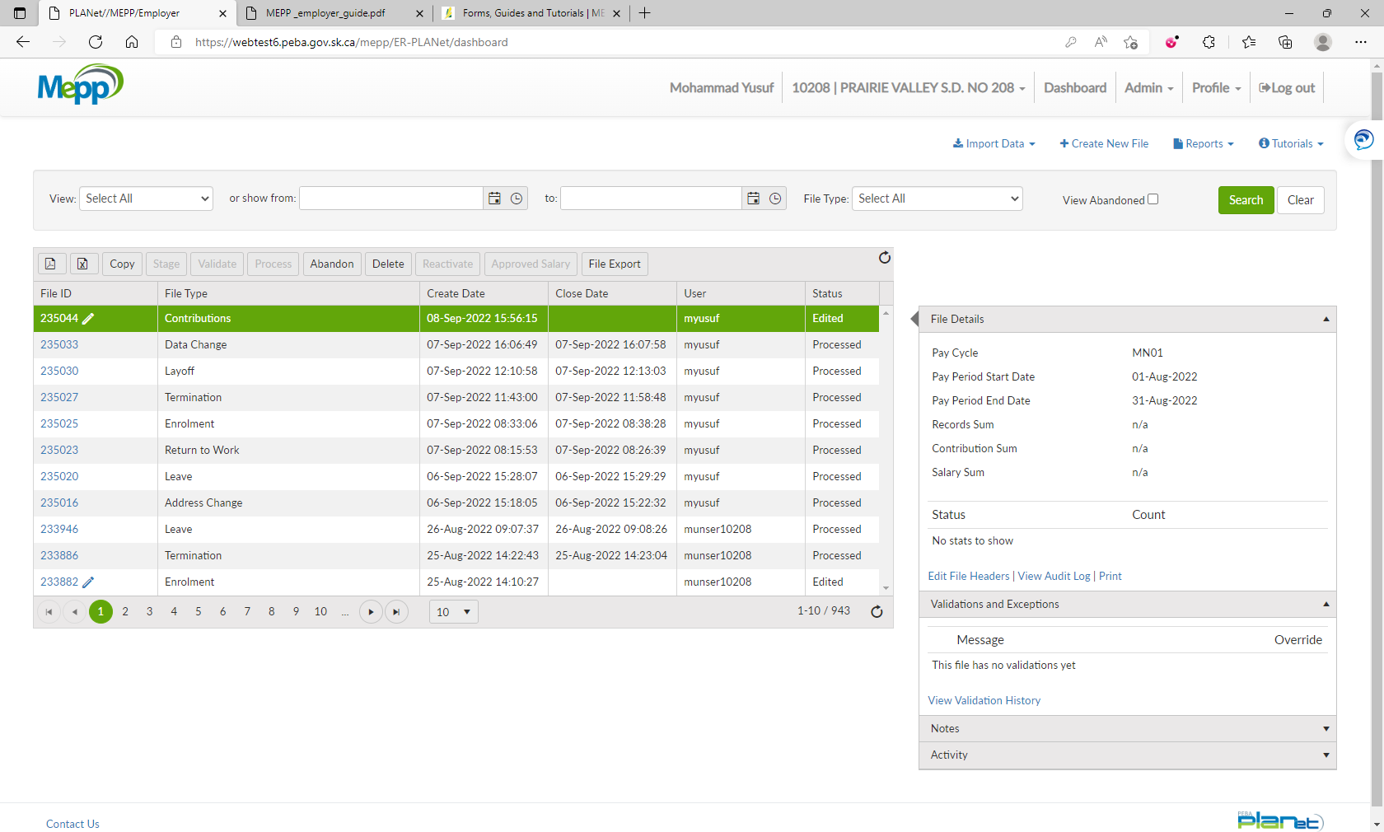

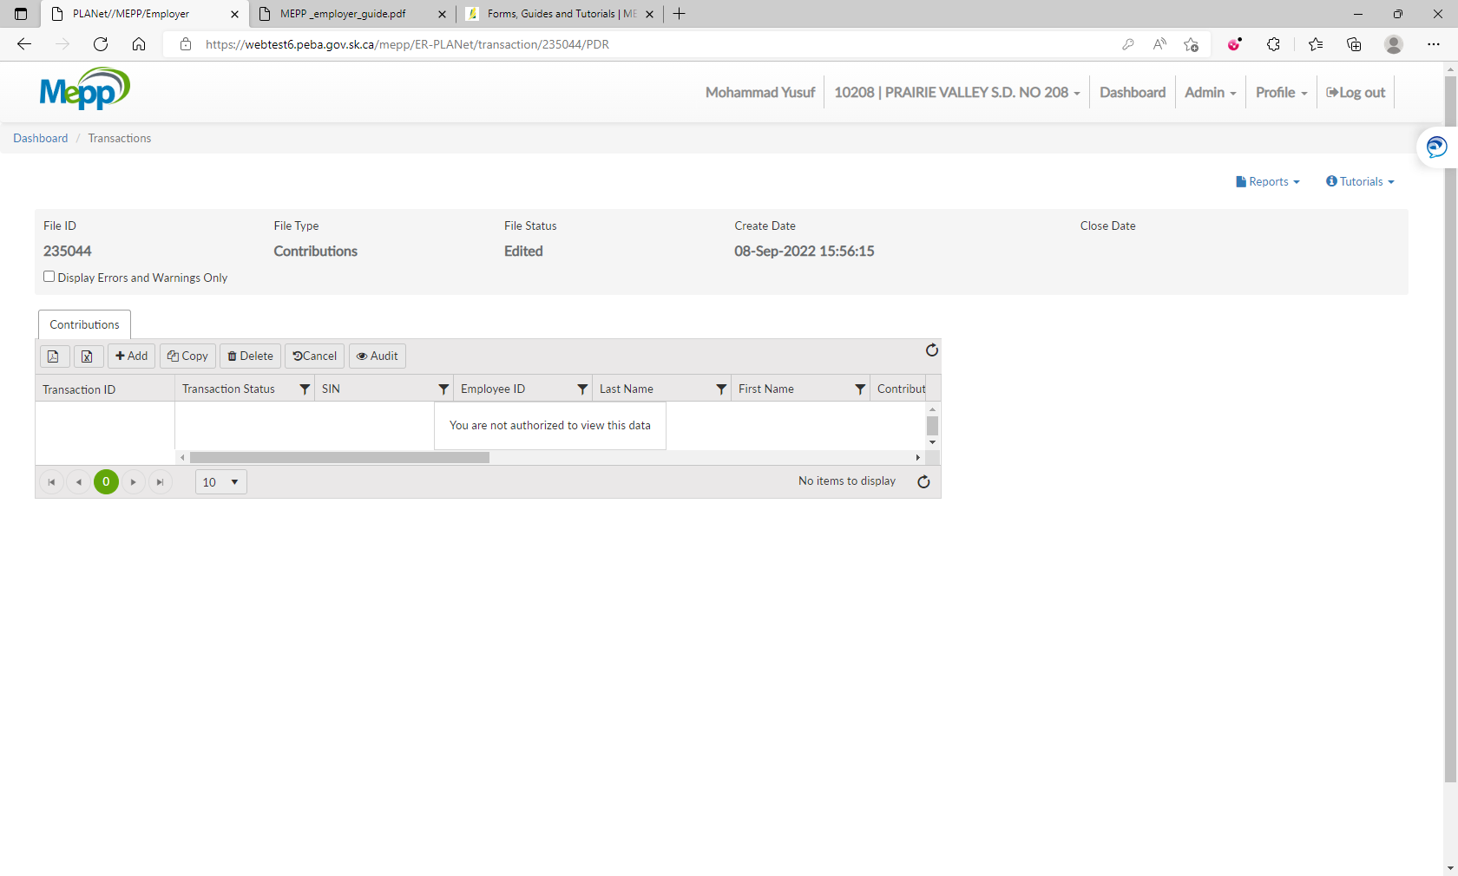

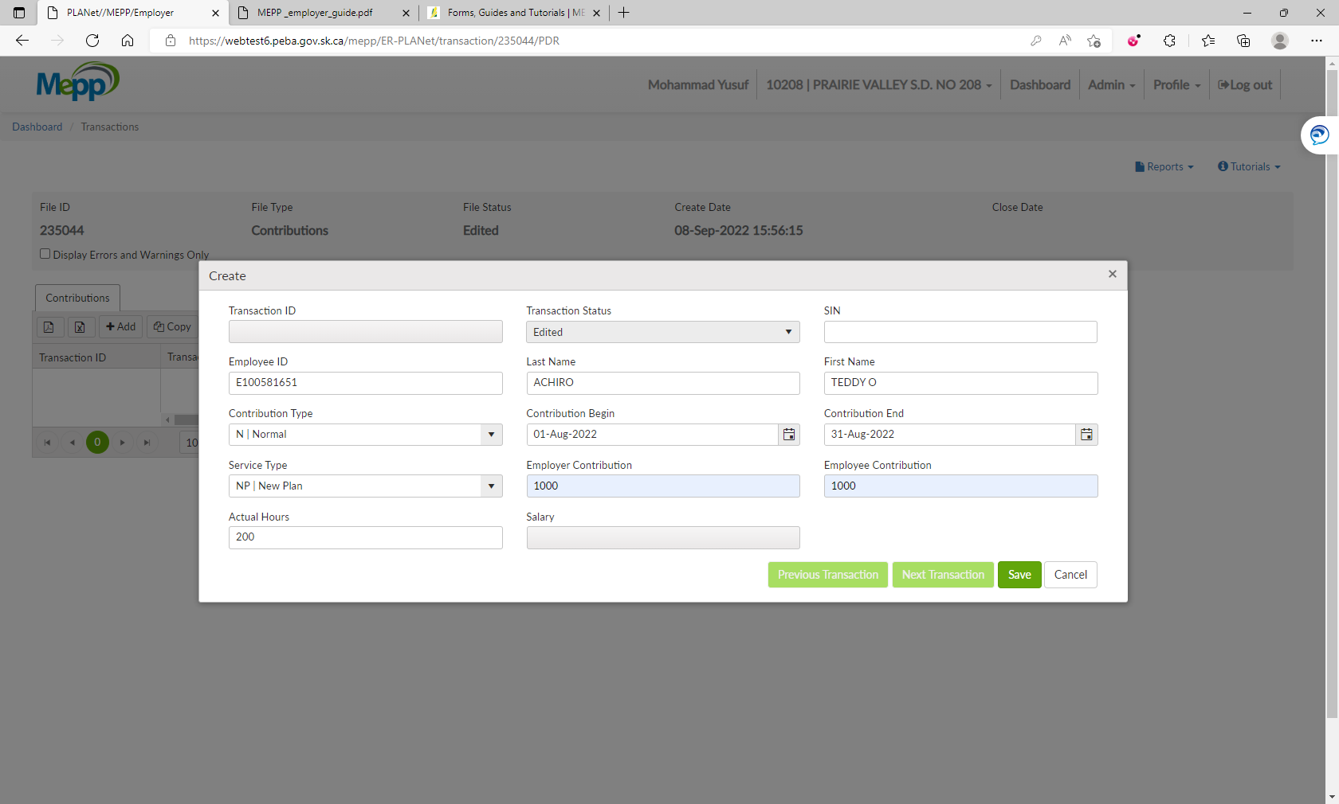

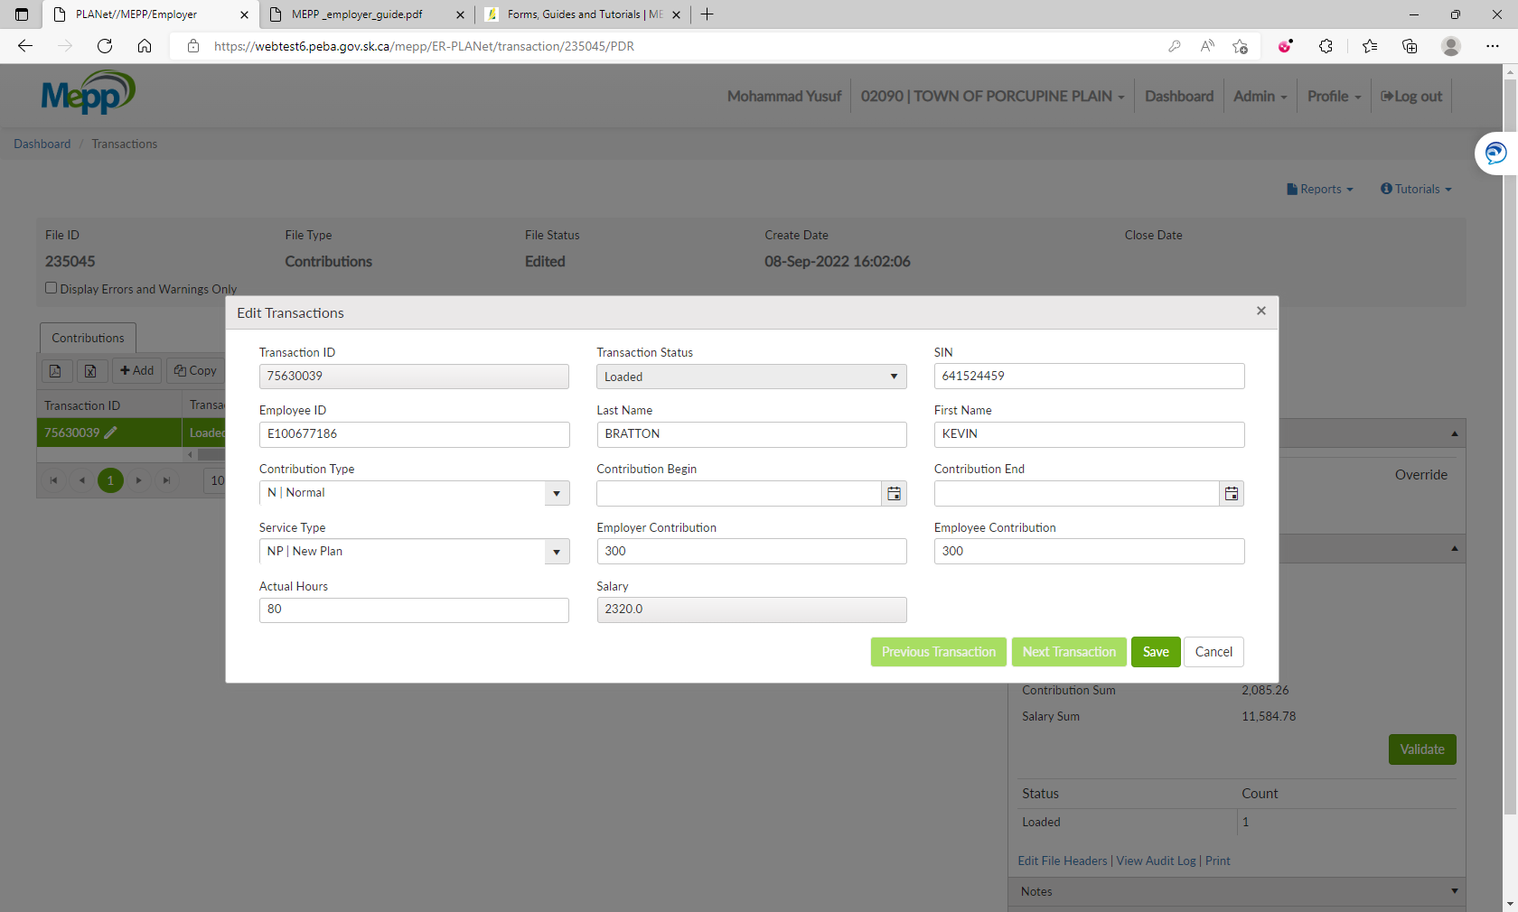

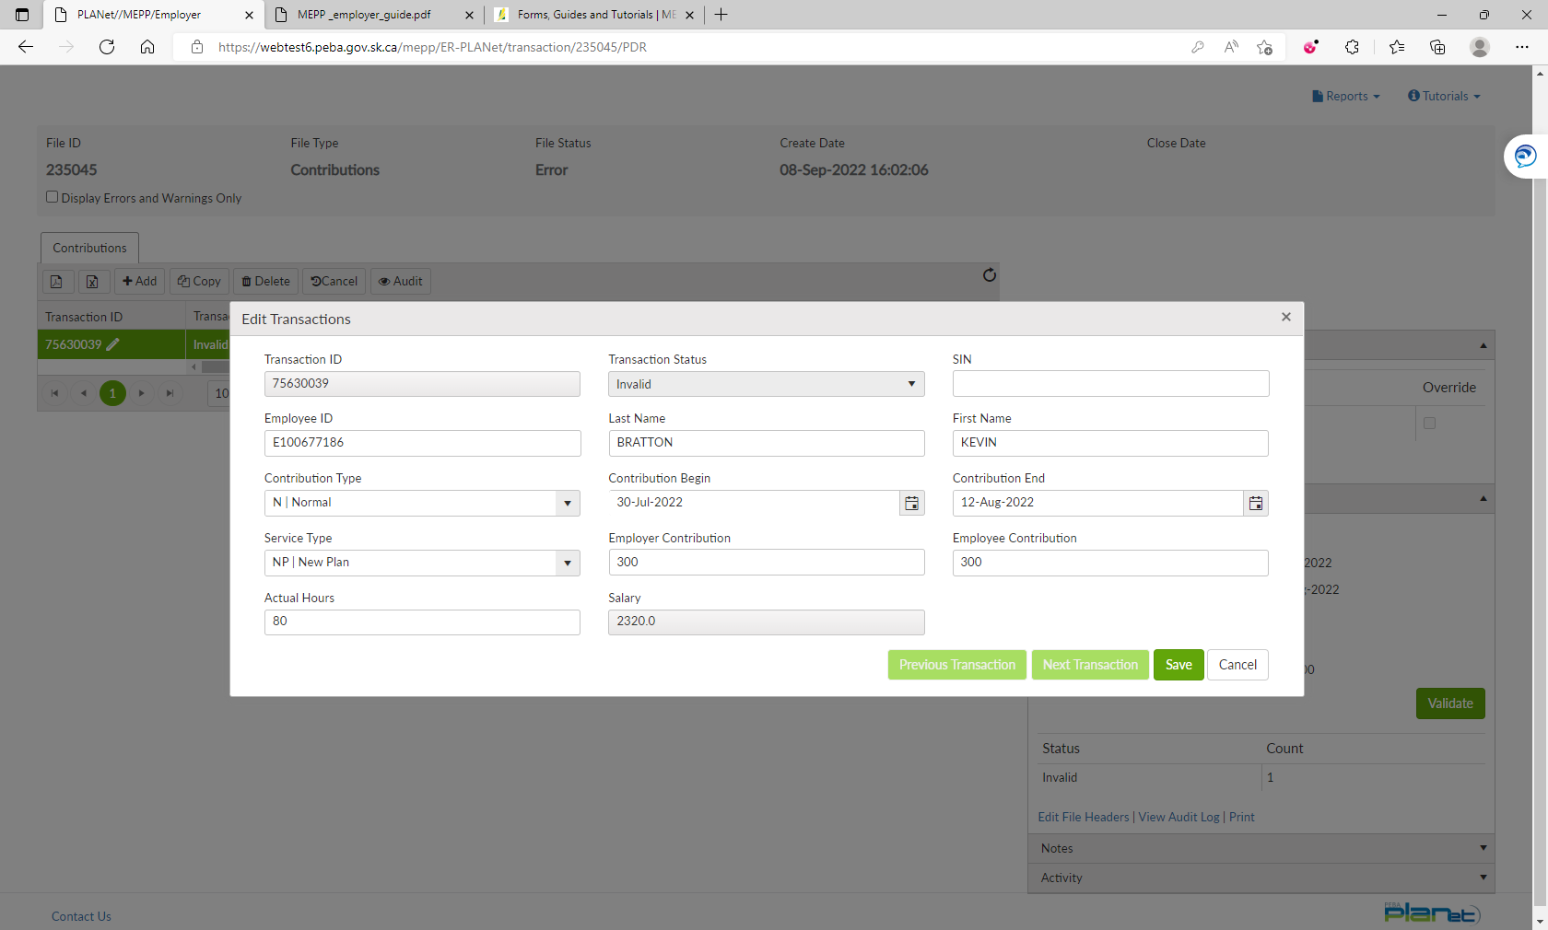

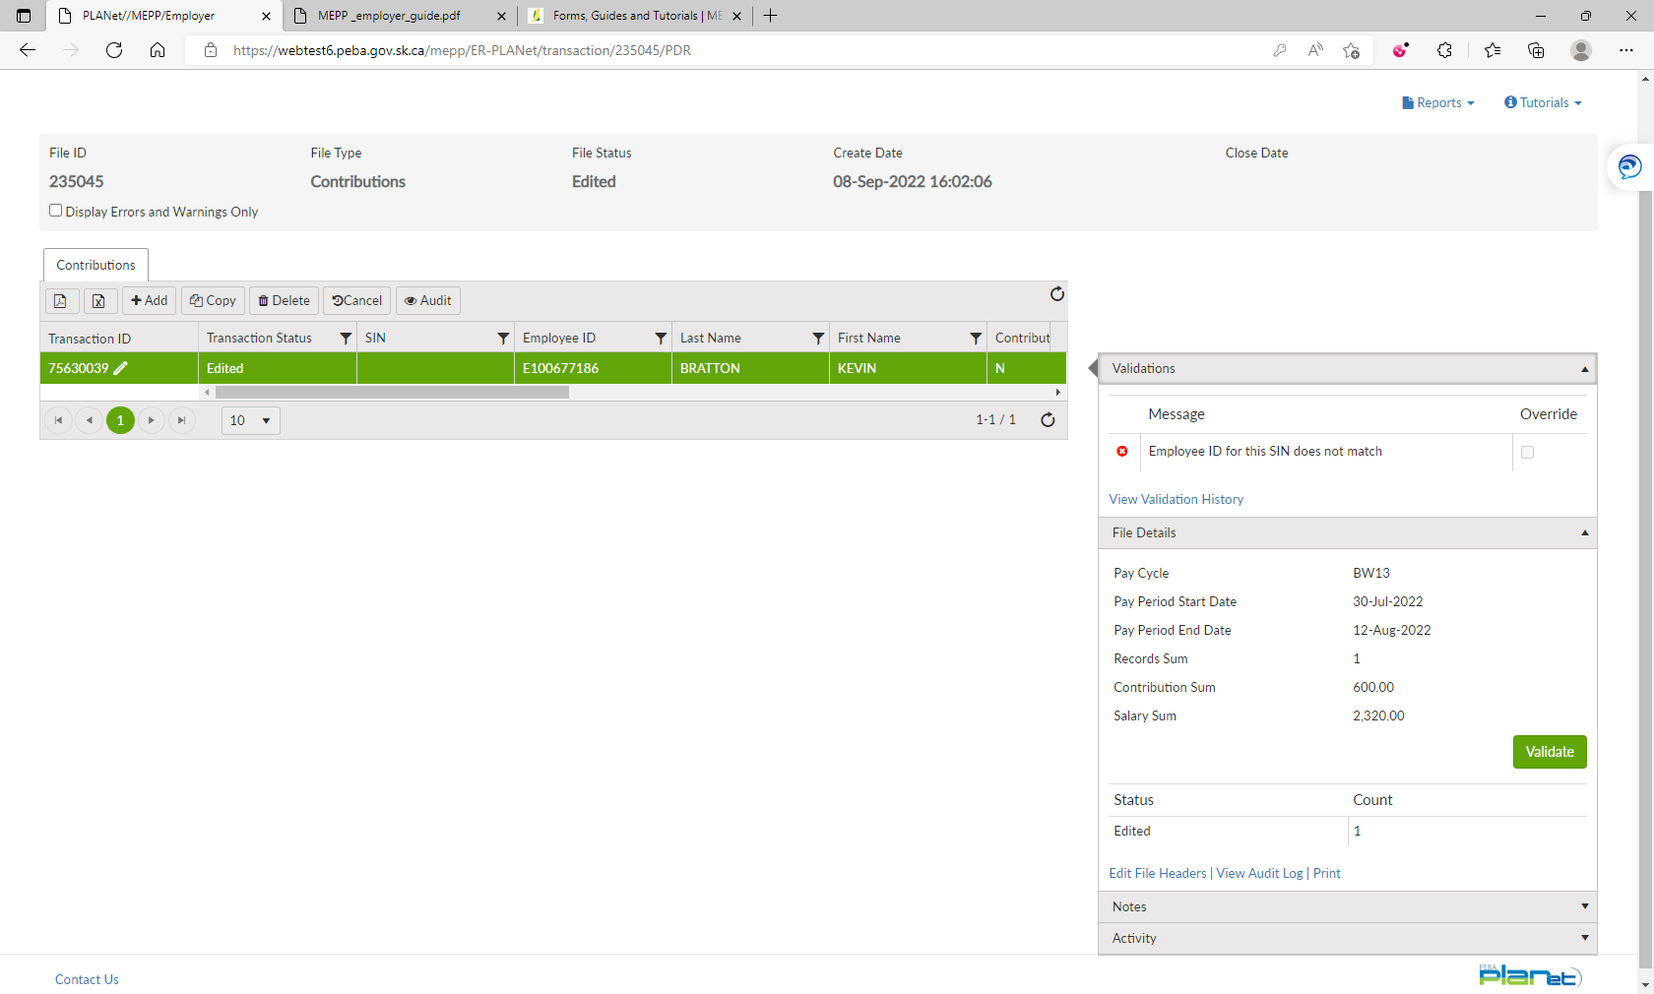

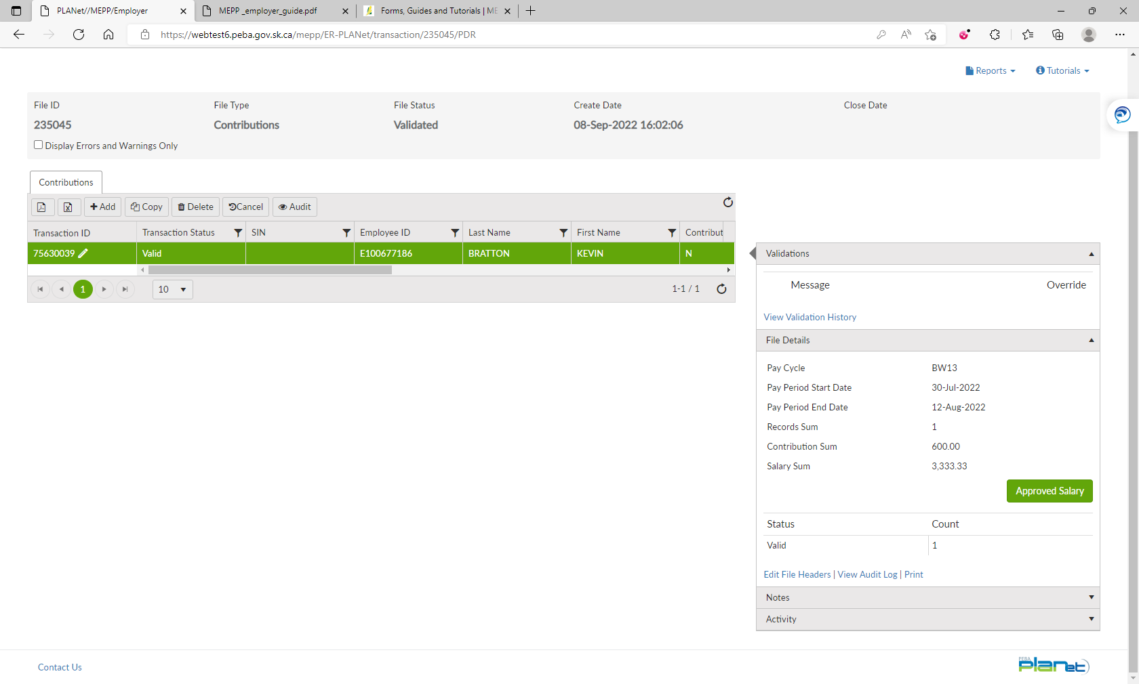

1. Under File Details, click on Validate.
2. Now, all the details available under File Details. Click on Approve Salary.



1. Click on Process.

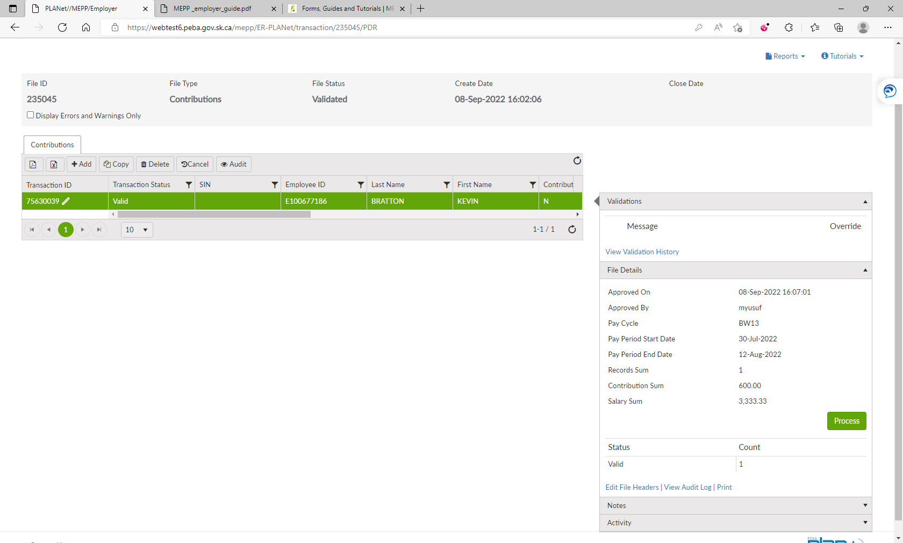

1. File is processed now.

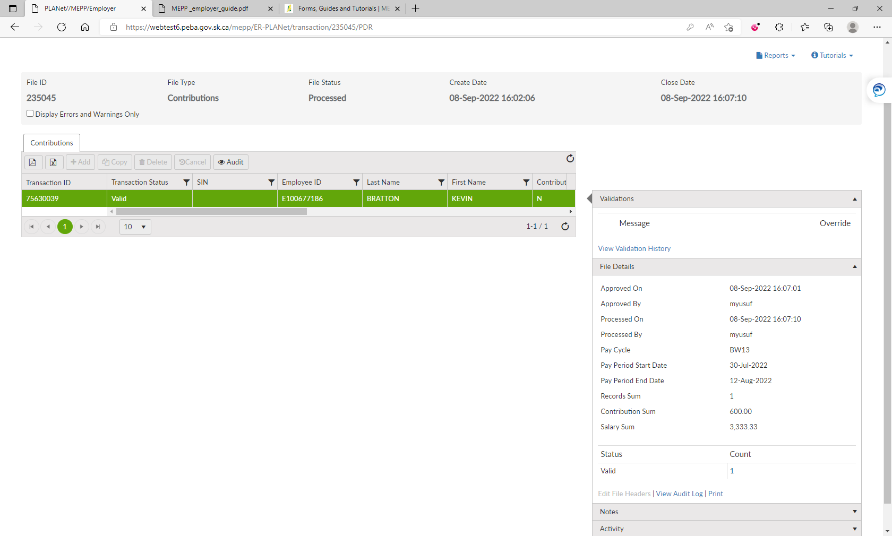

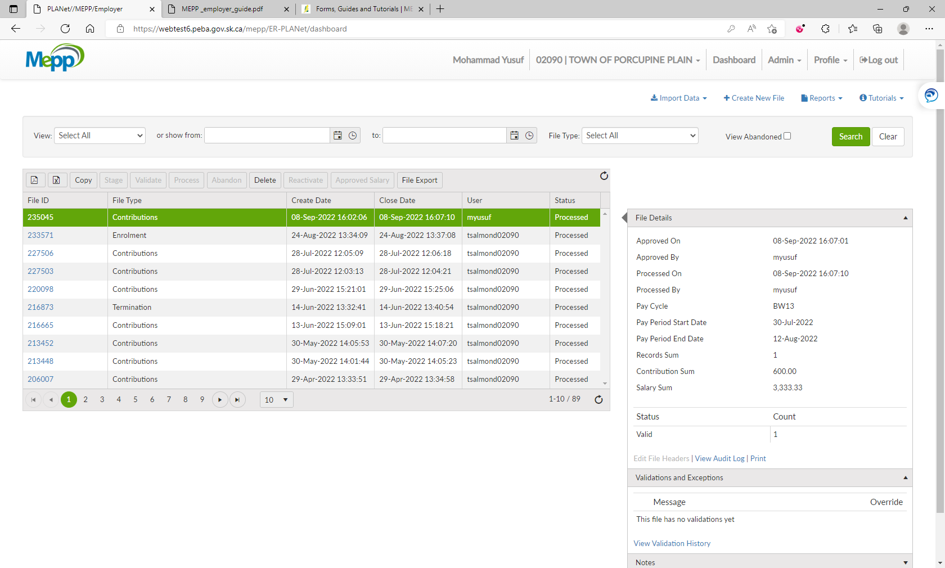

1. Now try to process the Contribution file having the same Pay Period Begin and End Dates.

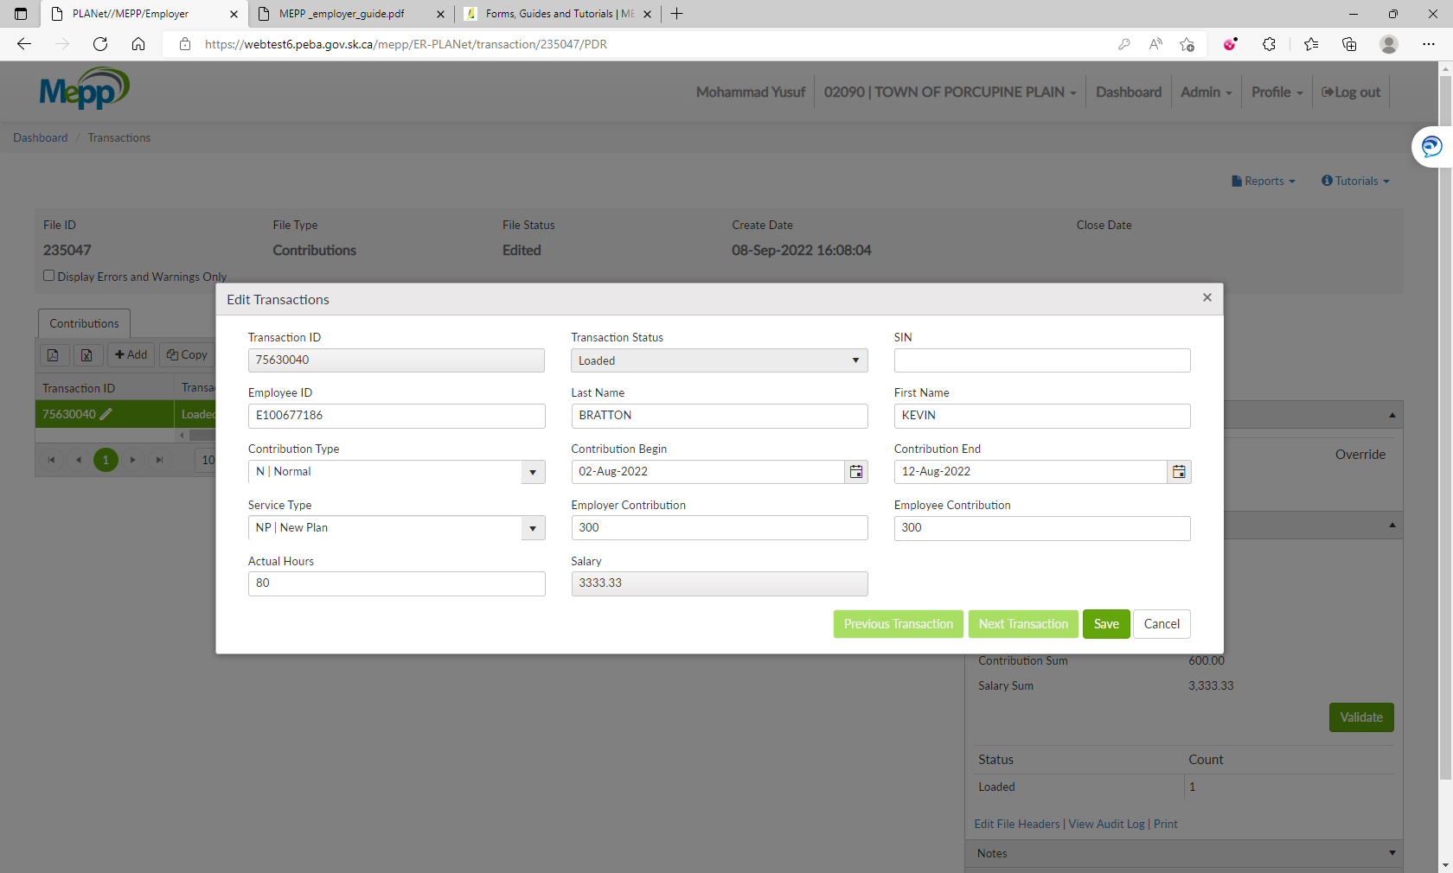

1. Under File Details, click on Validate.

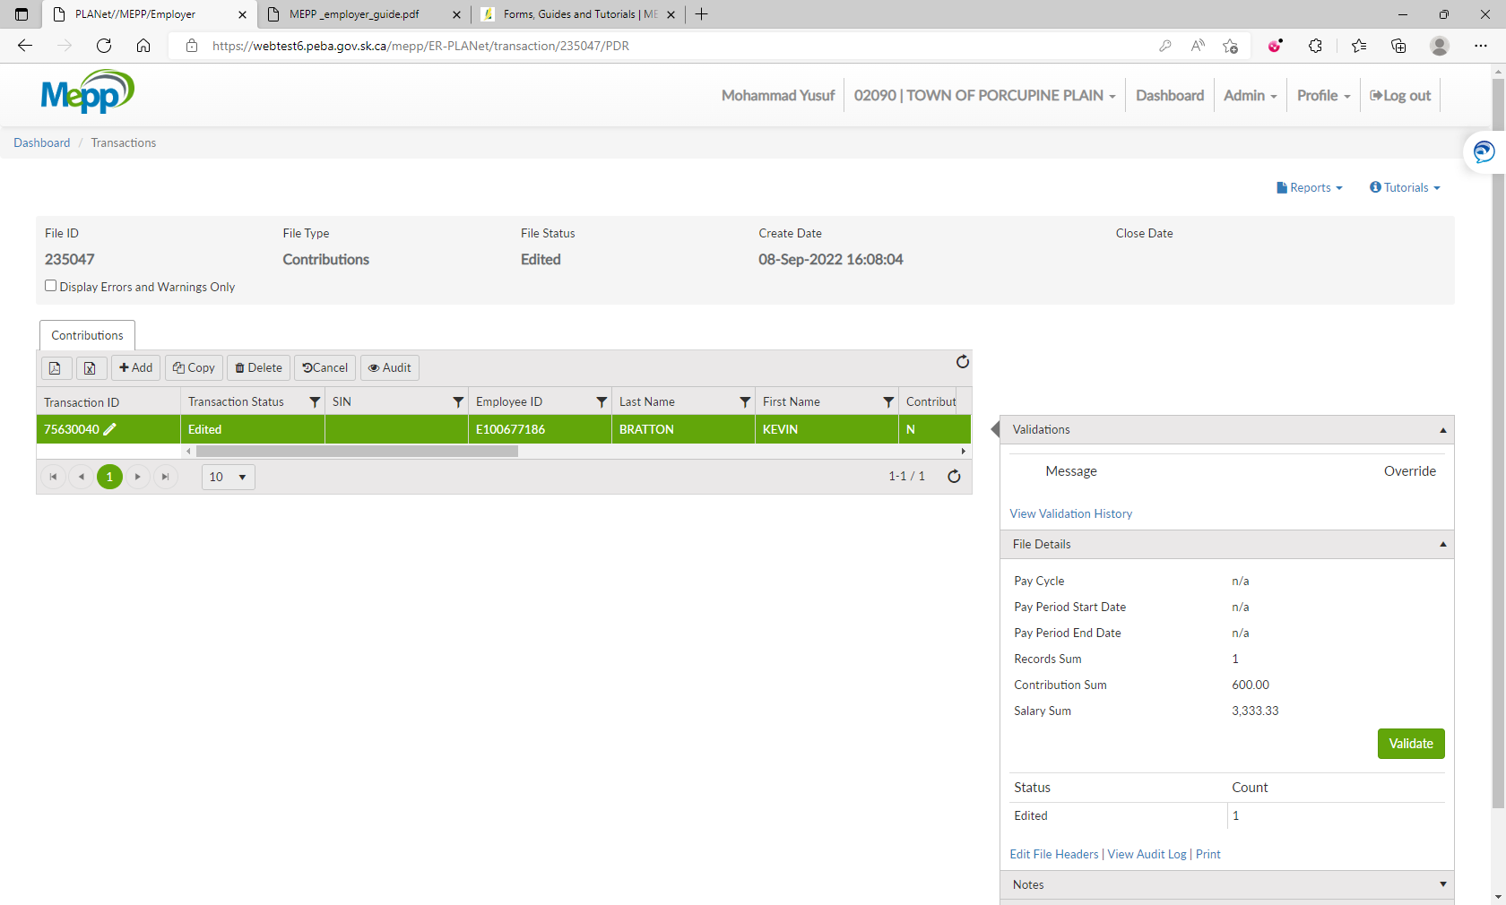

1. It will give you an error for the duplicate posting.

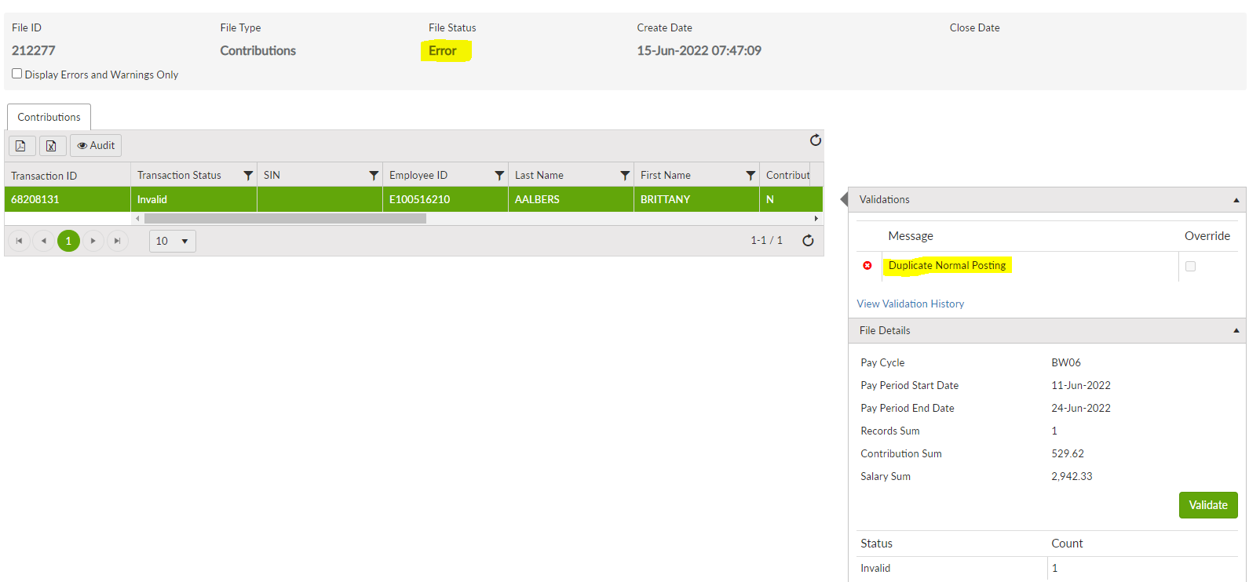

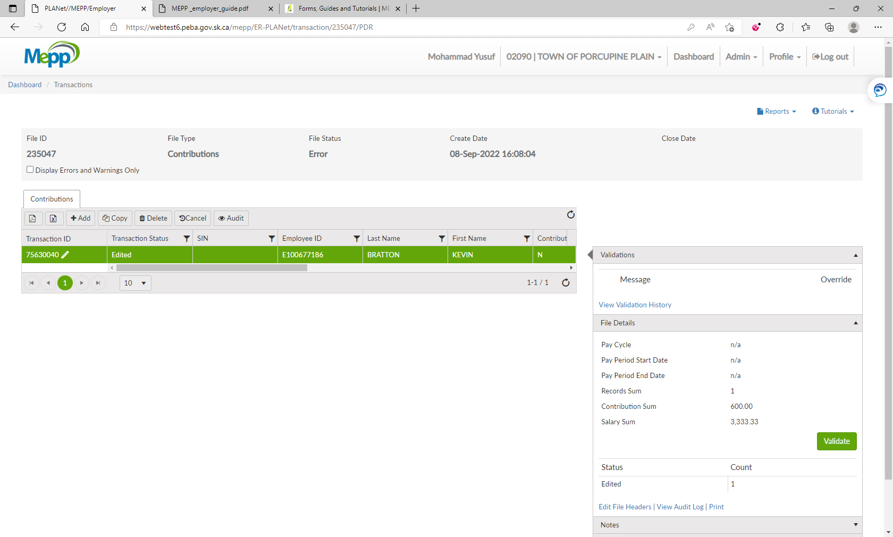

1. Under File Details, click on Edit File Headers.

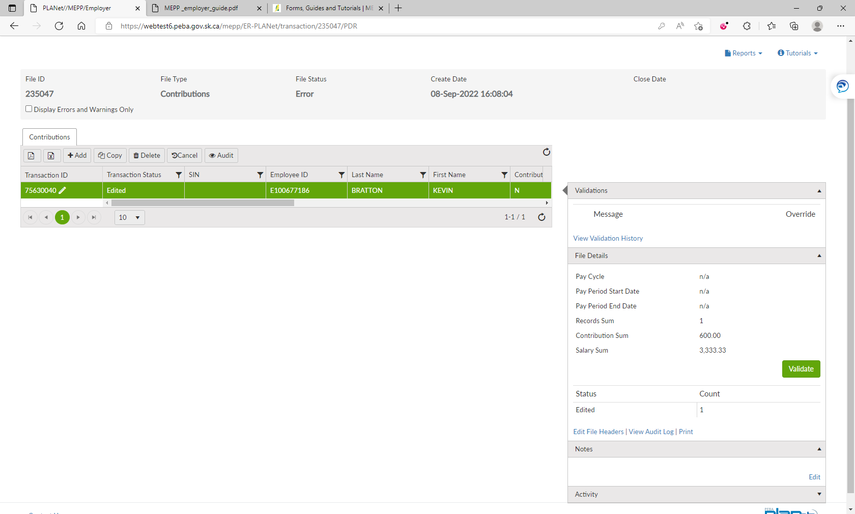

1. Change the Pay Period and save.

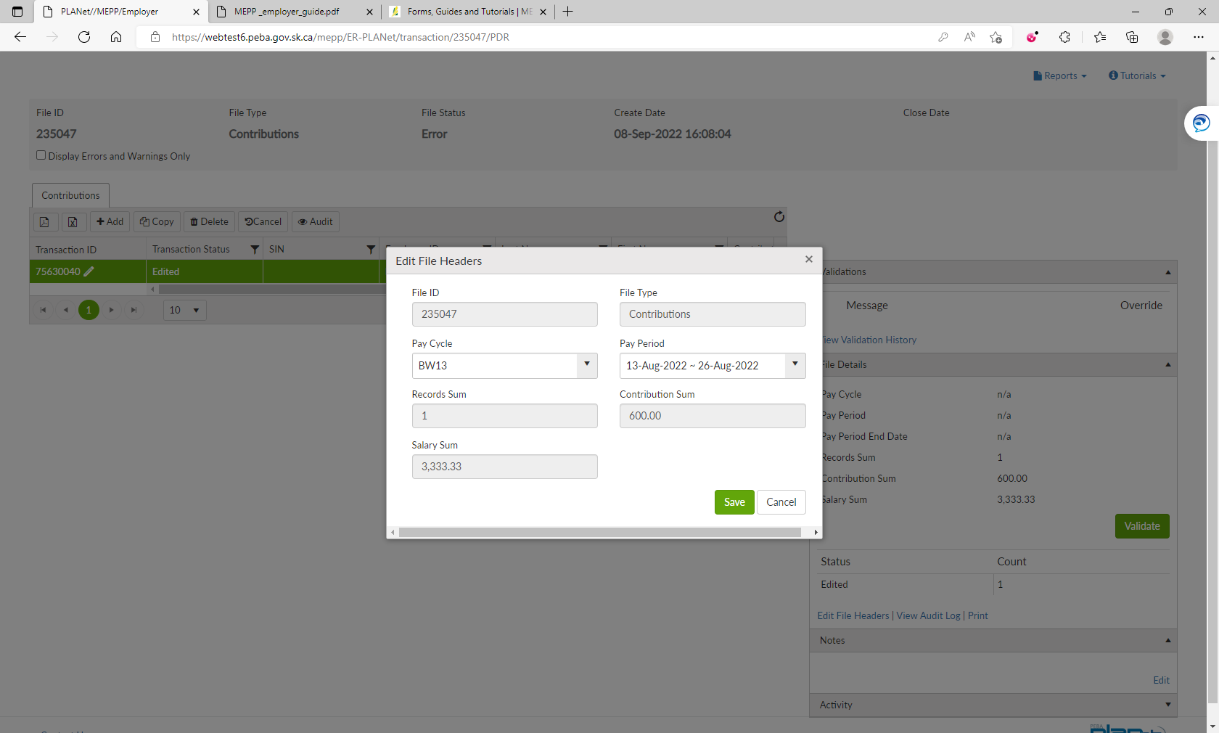

1. Also, change Contribution Begin and Contribution End dates in the transaction and save.

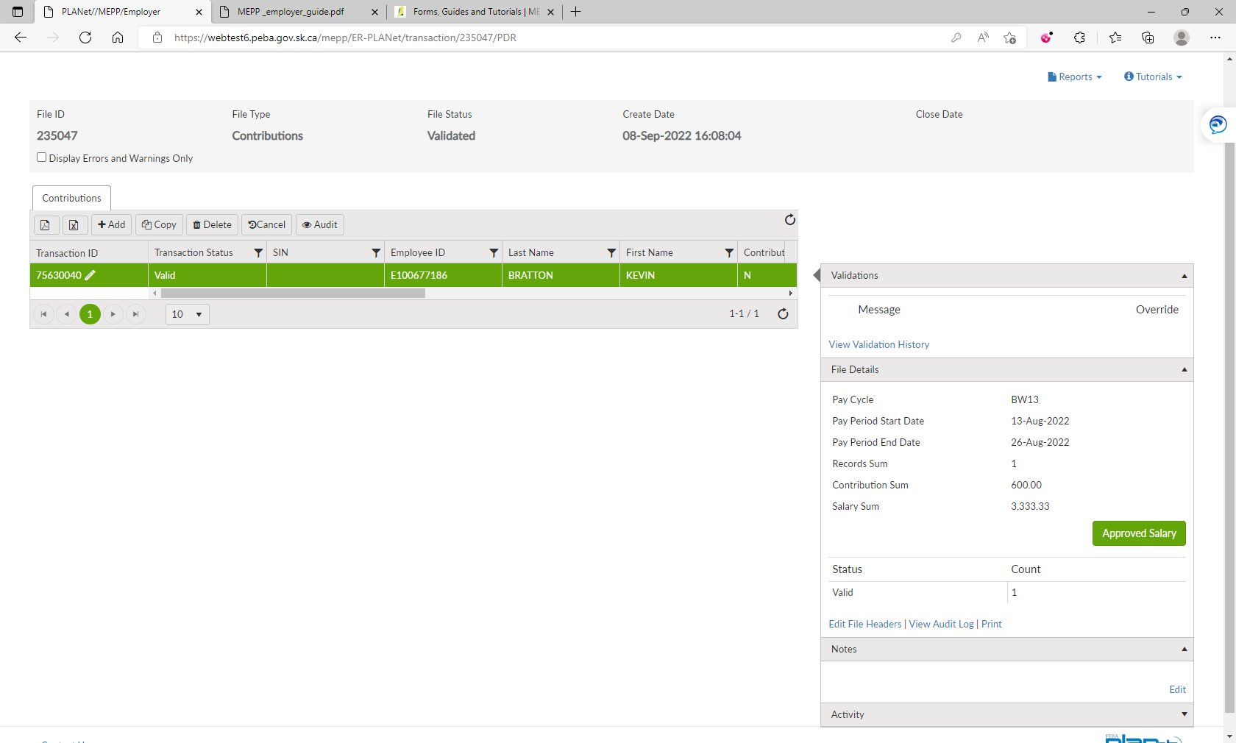

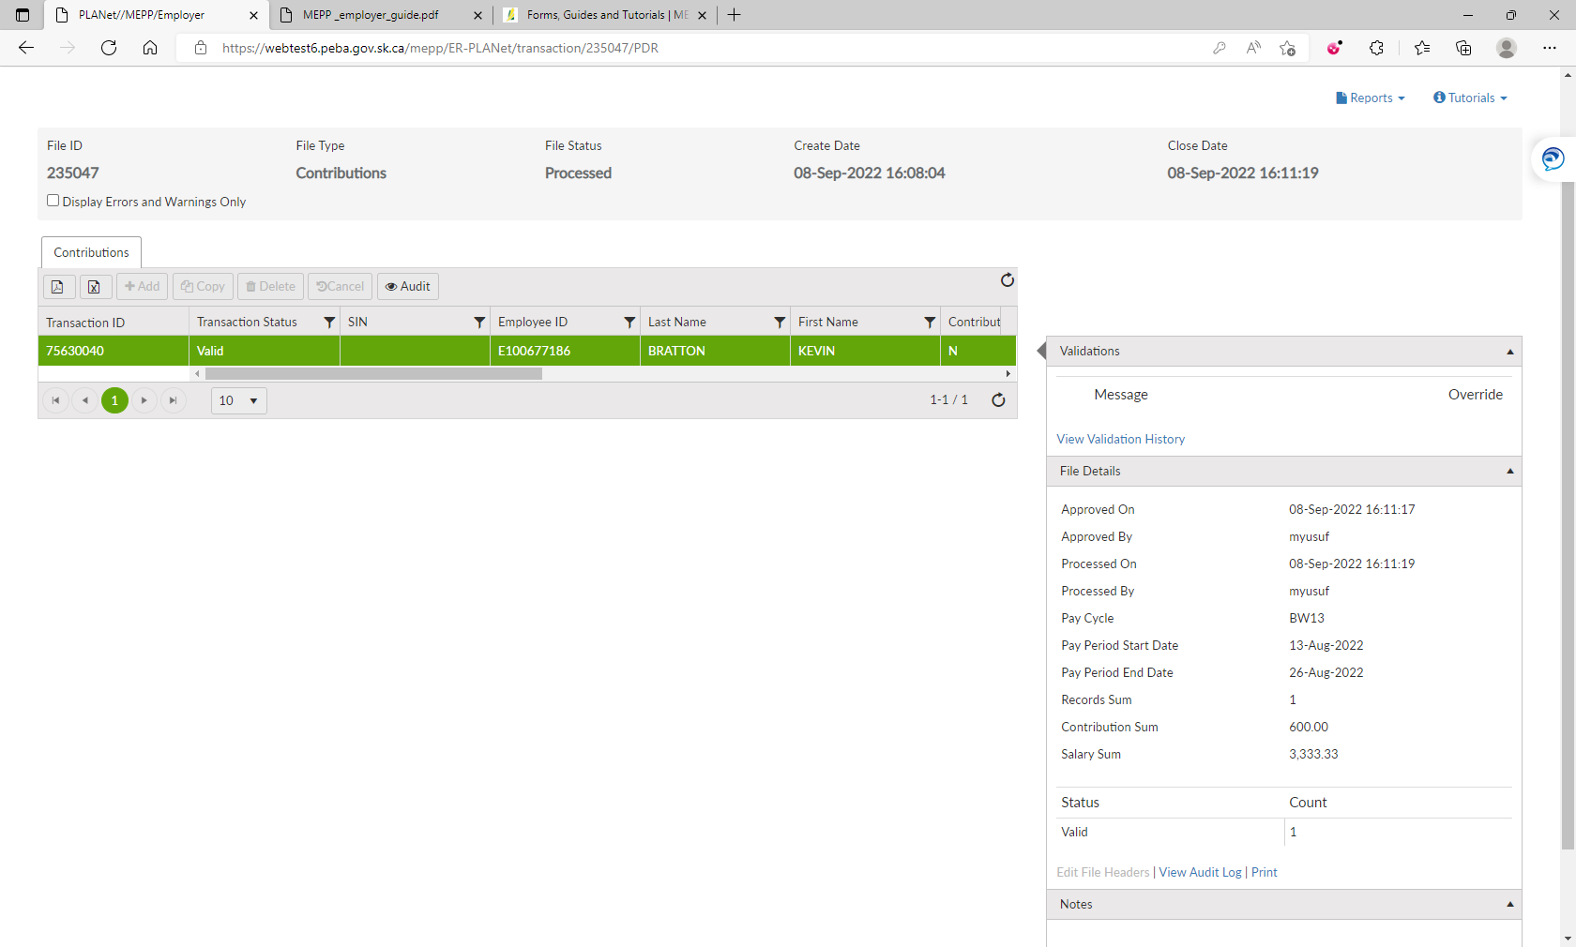

1. Now, validate, approve salary and process the file.
2. File is now processed.

